CMR Institute of Technology, Bangalore |  |  | 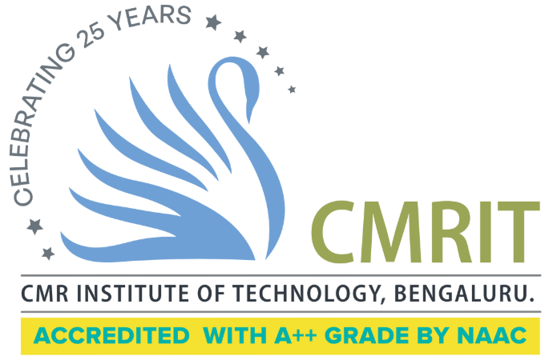
Department: Information Science & Engineering
Semester: VI | Section(s): A,B,C
Subject: Machine Learning |  | Code: BCS602
Course Instructor(s): Prof. Kamaleshwari, Prof. Sugunadevi, Prof. Nidhi Joshi
Course Duration: January 2026 – May 2026

 | Assignment-1
 | Issued Date: 15.03.2026 Submission Date: 19.4.2026
Q.No | Questions | Marks | CO | Blooms Level
1 | 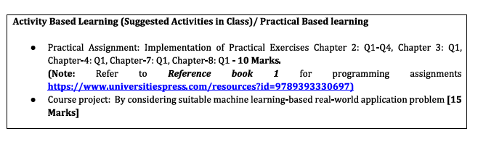 | 15 | CO1, CO2, CO3, CO4, CO5 | L1, L2, L3, L4, L5, L6

Course Instructor HOD

