CMR Institute of Technology, Bangalore |  |  | 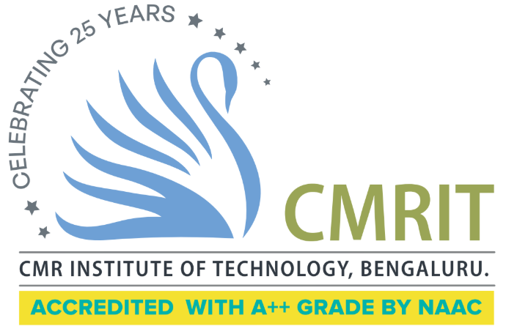
Department: Information Science & Engineering
Semester: VI | Section(s): A,B,C
Subject: Machine Learning |  | Code: BCS602
Course Instructor(s): Prof. Kamaleshwari, Prof. Sugunadevi, Prof. Nidhi Joshi
Course Duration: January 2026 – May 2026

 | Assignment-1
 | Issued Date : 2.2.2026 Submission Date : 3.2.2026
Q.No | Questions | Marks | CO | Blooms Level
1 | 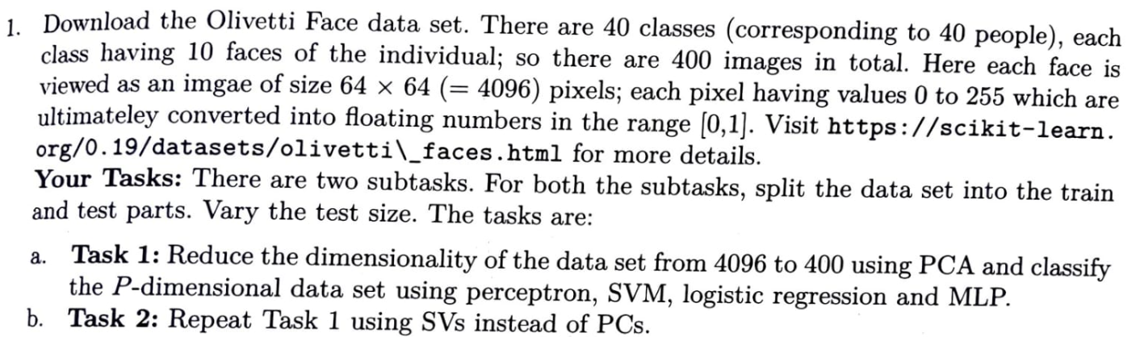  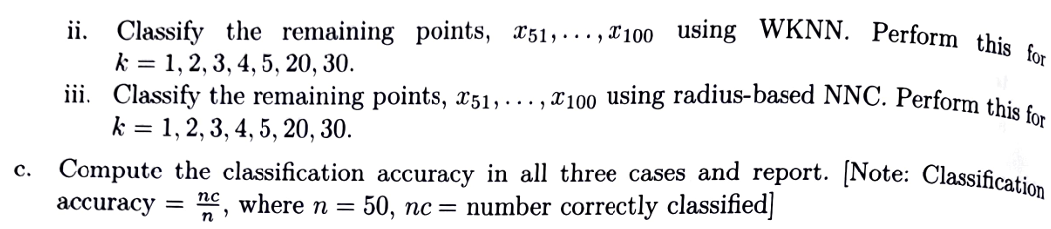 | 15 | CO2 | L3
2 |  | 10 | CO5 | L3
3 | 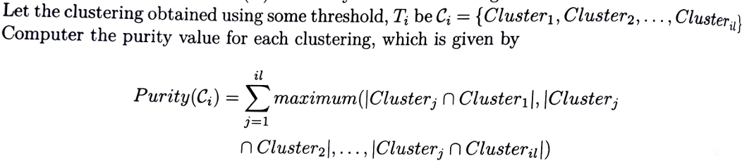 | 10 | CO5 | L3
4 | 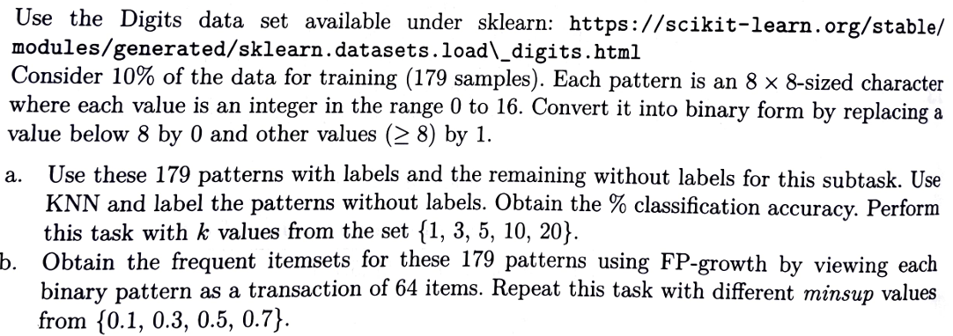 | 10 | C03 | L3
5 | 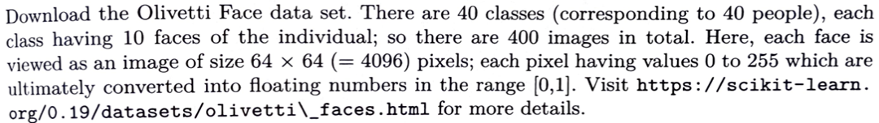  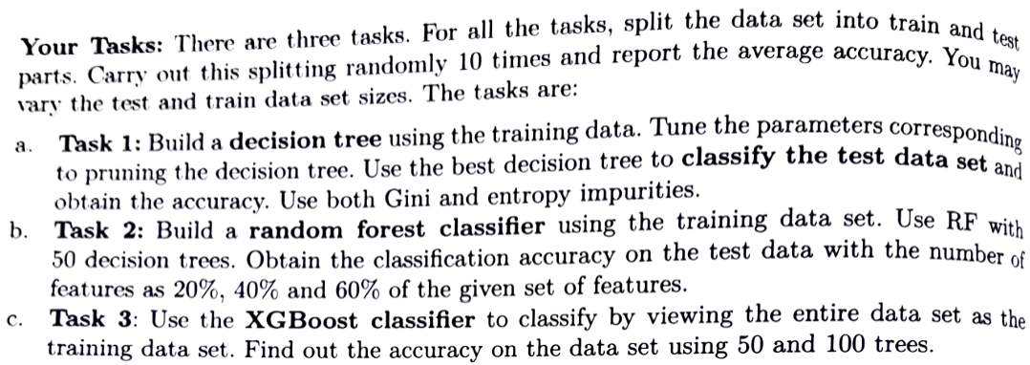 | 15 | CO3 | L3
6 | 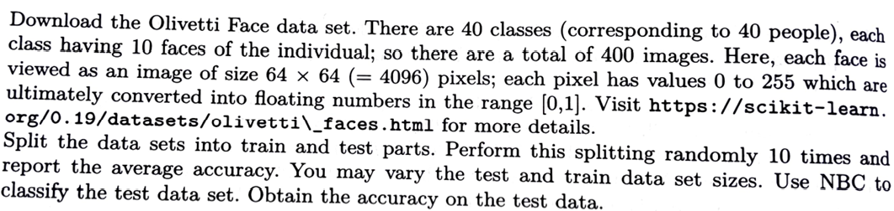 | 10 | CO4 | L3
7 | 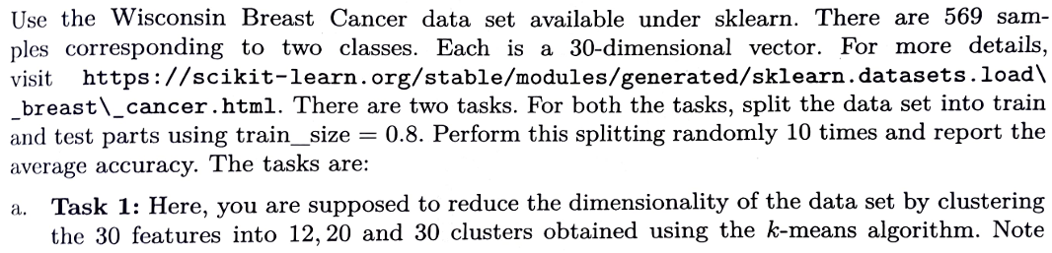  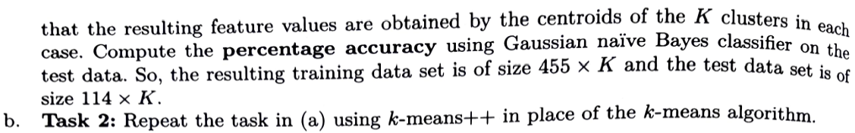 | 15 | CO4 | L3
8 | 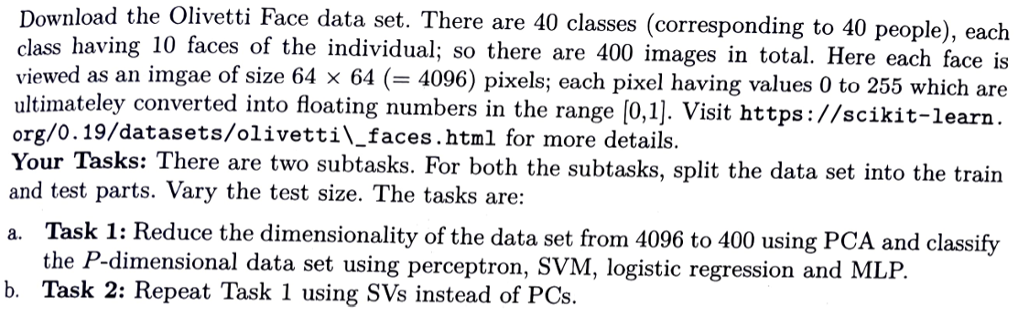 | 15 | CO1 | L3

Course Instructor HOD

