CMR Institute of Technology, Bangalore |  |  | 
Department(s): Information Science & Engineering
Semester: 03 | Section(s): -A,B&C | Lectures/week: 04
Subject: DBMS |  | Code: BCS403
Course Instructor(s): Prof. Komala Devi, Prof.Adbul, Prof.Jhanvi
Course duration: Feb 2026 to May 2026
Course Site: https://classroom.google.com/c/NzM3NTQyODY2NTQ0?cjc=a5yiqsn

Assignment-1 Issue Date: Submission Date:
Q.No | Questions | Marks | CO | Blooms Level
SET-1
HARD
1 | Discuss the main characteristics and the advantages of DBMS approach | 5 | CO1 | L2
2 | Discuss Canned transaction, Snapshot, Instance, Entities, Attributes, Tuples, Naive users, Parametric users, Causal users, DBA, Data abstraction, Three schema model in detail | 5 | CO1 | L2
3 | 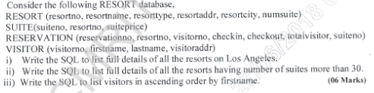 | 6 | CO3 | L3
 | 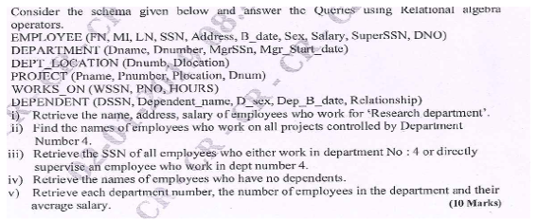 | 4 | CO3 | L3
SET-2
MEDIUM
1 | Explain data language and independence in detail? | 5 | CO1 | L2
2 | Explain three schema architecture in detail  Describe Cardinality Ratio, Total and Partial participation in detail | 3  2 | CO1 | L2
3 | Differentiate Primary key, Foreign key ,Relational schema, State and Snapshot | 3 | CO3 | L2
4 | Draw ER diagram of bank database  and convert it into relational schema | 4  3 | CO3 | L2
SET-3
LOW
1 | List four significant differences between a file-processing system and a DBMS. | 4 | CO1 | L1
2 | Explain the Conceptual Design with the ER Model with all the components? | 6 | CO1 | L2
3 | a.Mention the six fundamental operations of relational algebra and their symbols ?  b.Explain the constraints of Relational Model? | 3  2 | CO3 | L2
4 | describe the characteristics of Relations with suitable example for each | 5 | CO3 | L2

Course Instructor Signature/s CCI Signature HOD

